Home Security System using ESP32

# Requirements:

* ESP 32
* Servo Motor
* dht22
* pir-motion-sensor
* Servo Motor
* Buzzer

# Circuit diagram:

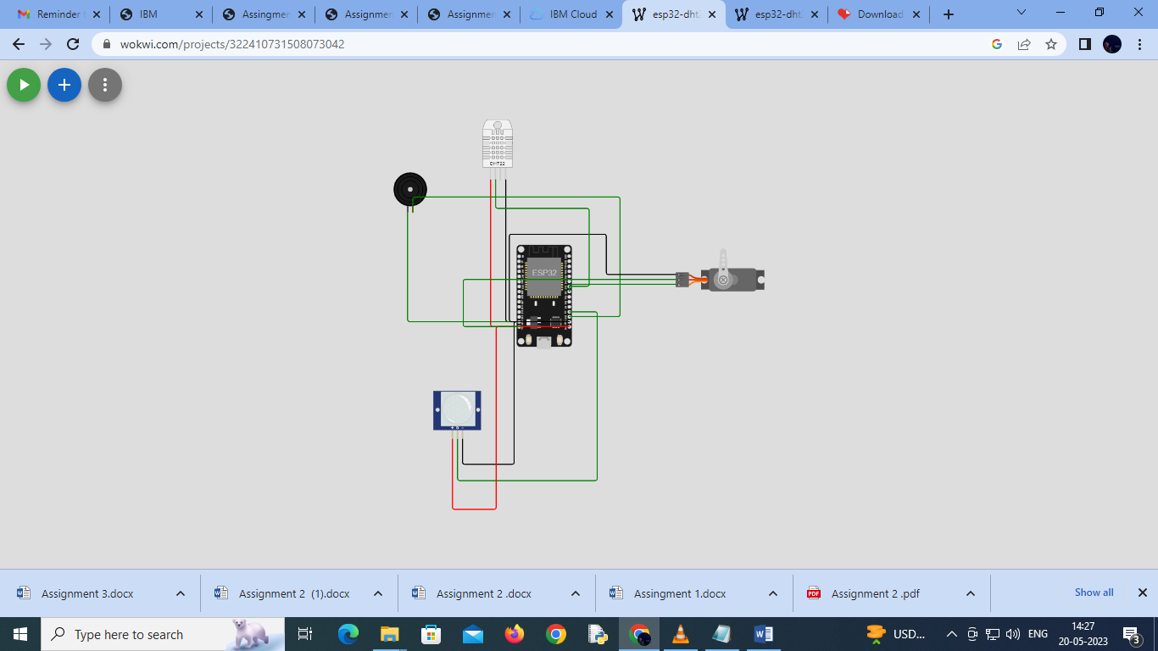

**Connection details**

* Buzzer
  1. Positive → Pin No 15
  2. Negative → GND
* Pir motion sensor

1. OUT → Pin No 2
2. VCC → VIN
3. GND → GND

* Servo Motor

1. PWM → Pin No 5
2. Negative → GND
3. Positive → VIN

* dht22

1. SDA → Pin No 18
2. VCC → VIN
3. GND → GND
4. NC → No connection

***Source Code:***

#include <ESP32Servo.h> #include <DHT.h>

const int pirPin = 2;

bool motionDetected = false;

const int dhtPin = 18; #define DHTTYPE DHT22

DHT dht(dhtPin, DHTTYPE); float temperature;

float humidity;

const int buzzerPin = 15;

const int servoPin = 5; Servo doorLock;

void setup() { pinMode(pirPin, INPUT); pinMode(buzzerPin, OUTPUT);

doorLock.attach(servoPin);

**Serial**.begin(9600);

}

void loop() {

motionDetected = digitalRead(pirPin) == HIGH;

if (motionDetected) {

tone(buzzerPin, 1000); doorLock.write(90); delay(8000); doorLock.write(0);

} else { noTone(buzzerPin);

doorLock.write(0);

}

humidity = dht.readHumidity(); temperature = dht.readTemperature(); **Serial**.print("Temperature: "); **Serial**.print(temperature); **Serial**.print(" C, Humidity: "); **Serial**.print(humidity); **Serial**.println(" %");

delay(200);

}

Link: https://wokwi.com/projects/322410731508073042